Analyzing Graphs of Functions and Piecewise-Defined Functions Section 1.7

Test for Symmetry

Consider an equation in the variables x and y.

Symmetric with respect to the y-axis: Substituting –x for x results in equivalent equation.

Symmetric with respect to the x-axis: Substituting –y for y results in equivalent equation.

Symmetric with respect to the origin: Substituting –x for x and –y for y results in equivalent equation.

Determine whether the graph of the equation is symmetric with respect to the x-axis, y-axis, origin, or none of these.

1. 2.

3. 4.

Identify Even and Odd Functions

Even function: f(–x) = f(x) for all x in the domain of f. (Symmetric with respect to the y-axis)

Odd function: f(–x) = –f(x) for all x in the domain of f. (Symmetric with respect to the origin)

Determine if the function is even, odd, or neither.

5.

6. 7.

8. 9.

Graph Piecewise-Defined Functions
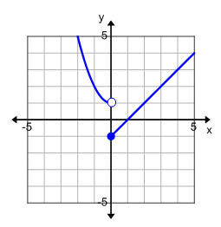
Evaluate the function for the given values of x.

10. _________ ________
_________

11. ________ _________ ________
________

Graph the function.
12.

13.

Greatest integer function: $f(x)=⟦x⟧$ $⟦x⟧$ is the greatest integer less than or equal to x.

Evaluate

14. $⟦1.3⟧$ = _______ $⟦-0.2⟧$ = _______ $⟦5.6⟧$ = _______ $⟦3⟧$ = _______

15. Graph $p(x)=⟦x-1⟧$
x | $$p(x)=⟦x-1⟧$$

16. A new job offer in sales promises a base salary of $3000 a month. Once the sales person reaches $50,000 in total sales, he earns his base salary plus a 4.3% commission on all sales of $50,000 or more. Write a piecewise-defined function (in dollars) to model the expected total monthly salary as a function of the amount of sales, x.

Investigate Increasing, Decreasing, and Constant Behavior of a Function

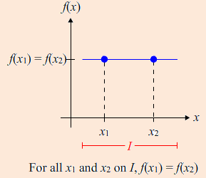
Increasing Decreasing Constant
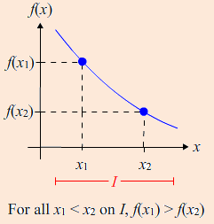
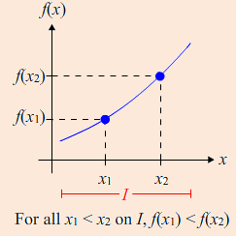

Use interval notation to write the interval(s) over which is increasing, decreasing, and constant.

17. Increasing: ________________ 18. Increasing: ________________

Decreasing: _______________ Decreasing: _______________

Constant: _________________ Constant: _________________

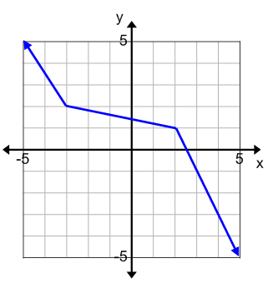
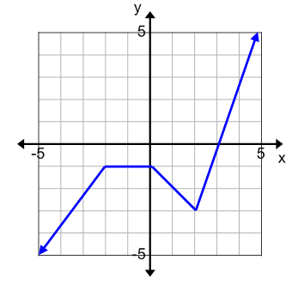

Determine Relative Minima and Maxima of a Function

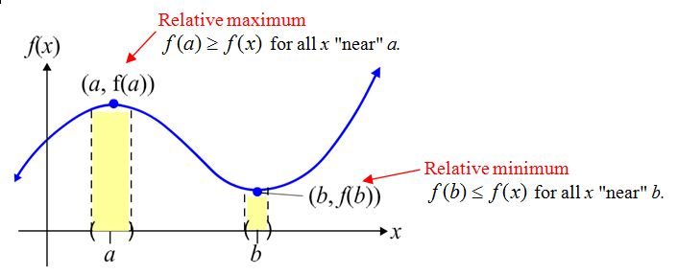

Identify the location and value of any relative maxima or minima of the function.
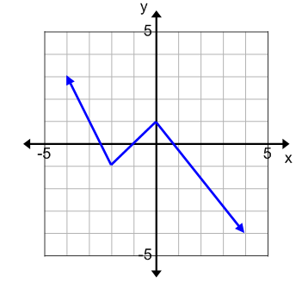
19. The point ________ is the lowest point in a small interval

surrounding x = ____.

At x = ____ the function has a relative minimum of _____.

The point ________ is the highest point in a small interval

surrounding x = ____.

At x = ____ the function has a relative maximum of _____.

20.
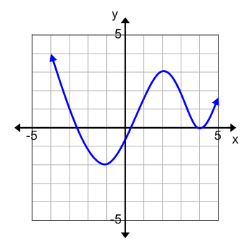

At x = ____ the function has a relative minimum of _____.

At x = ____ the function has a relative minimum of _____.

At x = ____ the function has a relative maximum of _____.

